

MIDDLE EAST TECHNICAL UNIVERSITY

Electrical & Electronics Engineering

Hardware Project

EE 464 – Static Power Conversion - II

Instructor:

Assist. Prof. Dr. Ozan KEYSAN

Students:

Huzeyfe Hintoglu - 2093920

Enes Ayaz - 2093318

Ali Aydın - 2093326

Date: 04.06.2019



Table of Contents

Introduction 1

# Introduction

In our hardware project of the EE464 course, we are asked to design an Isolated Power Supply. In this project, the design, simulations and hardware implementations are to be performed for hardware project. As Anka Inc. group, we have chosen the project designing an Isolated Flyback Converter. The specifications are as follows;

|  |  |
| --- | --- |
| Minimum Input Voltage (V) | 210 Vac |
| Maximum Input Voltage (V) | 230 Vac |
| Output Voltage (V) | 15 |
| Output Power (W) | 15 |
| Output Volt. Peak-to-Peak Ripple (%) | 5 |
| Line Regulation (%) | 3 |
| Load Regulation (%) | 3 |

Table 1: Flyback Converter Specifications

The main motivation selecting this topology is to overcome efficiency problems as our output current value is smaller, which results in less power loss in overall system. Also, there is no 3rd winding in transformer designed for Flyback Converter as well as output inductance for filtering purposes as in Forward Converter topology.

# 1. Flyback Converter Design

Our input voltage is AC voltage with 210 Vrms. Firstly, we establish the single phase full bridge rectifier to convert AC to DC and the DC voltage is filtered by DC-Link Capacitor. Then, a Flyback Converter is established by PI controller. PI controller is required to adjust the output power 15 V for not considering input voltages change.

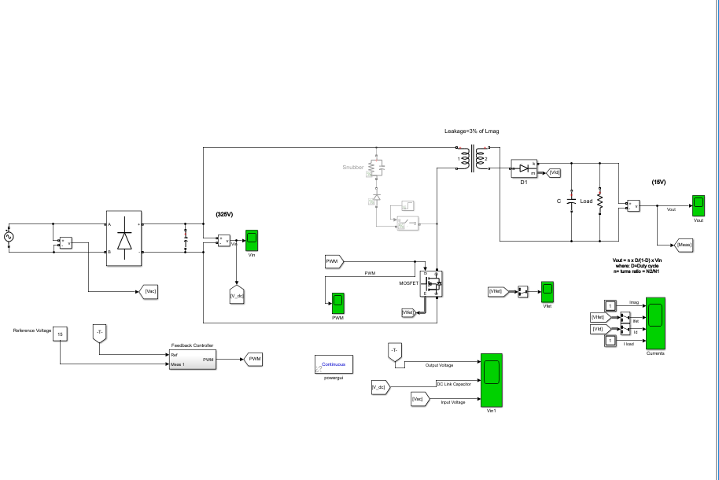

Figure 1: Simulink Setup of Flyback Converter

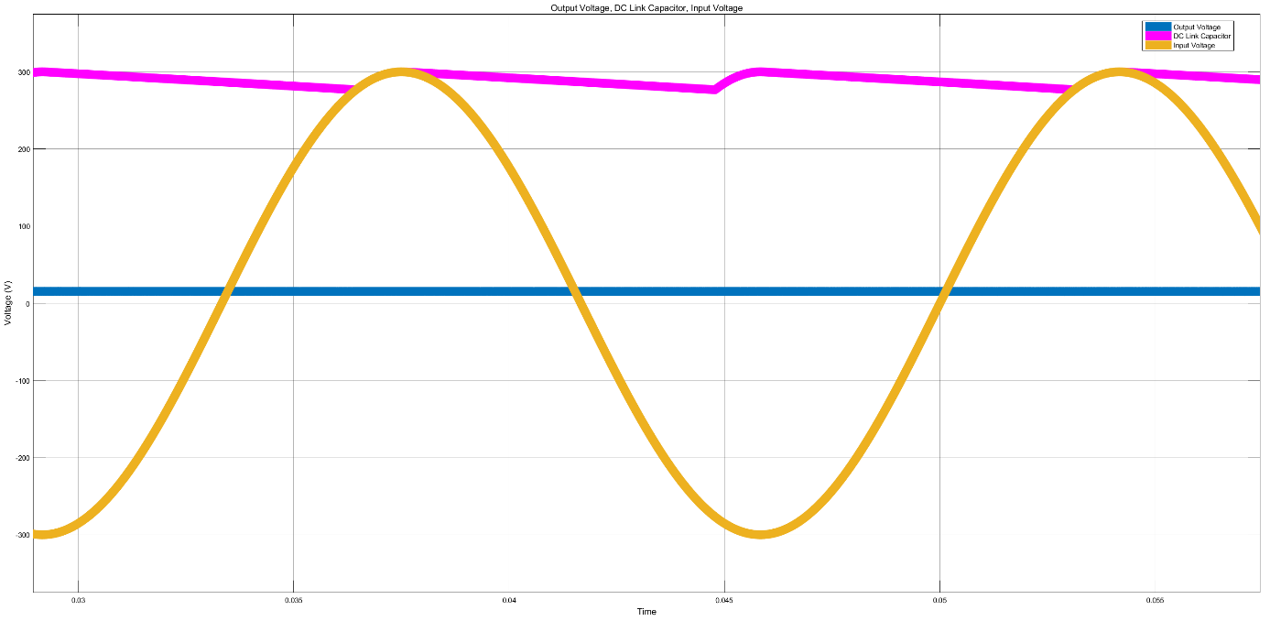

Figure 2: Inputs and Output Voltages of the Flyback Converter

## 1.1. Steady State Operation and Calculations

There are 5 steps to calculate the parameters to provide specification:

1. DC link capacitor determination for Single Phase Rectifier:

DC link capacitor is determined by AC voltage and frequency with desired ripple at output of the single phase rectifier.

$C_{dc}=\frac{2*V_{line}^{2}-V_{Dc}^{2}}{P_{in}\left(1-D_{ch}\right)f_{l}}$

$$V_{line}=210 V ( minimum)$$

$$V_{Dc}=280 V ( minimum)$$

$$P_{in}=P_{out}*Efficiency$$

$$f_{l}=50 Hz and Dch=0.2 ( charging duty)$$

The DC link capacitor is calculated easily as 33uF, 400 V.

1. Magnetizing Inductance is calculated by formula:

$$L_{m}=\frac{{\left( V_{DC}D_{max}\right)}^{2}}{2P_{in}*f_{s}*K_{rf}}$$

Maximum duty can be selected for mode of converter. We want our converter to operates at discontinuous conduction mode. Thus, standard duty ratio is near the 0.3. Maximum duty is 0.45. Ripple factor (Krf) is 1 at DCM and it is between 0.2 and 0.5 at CCM. Switching frequency was determined as 40 kHz.

$$L_{m}=10.58mH$$

1. Calculation of Peak Current of Switch

$$ΔIds=\frac{V_{dc} D_{max}}{L_{m}f_{s}}$$

$$I_{eds}=\frac{P_{in}}{V_{DC}D_{max}}$$

$$I_{ds}^{peak}=I_{edc}+\frac{ΔI_{ds}}{2}=0.297A$$

The calculation is important to determine the CCM and DCM mode. Change in switch current is equal to half of peak current or equals to I_eds.

1. Determination of primary side Turn number

$$N_{p}=\frac{L_{m}I_{ds}^{peak}}{B_{sat}*A_{e}}$$

Minimum turn number depends on core. The core area and saturation flux density.

They are found at our core datasheet.

$$A_{e}=233 mm^{2}$$

$$B_{sat}=0.3T$$

$$N_{p}=45.06$$

1. Determination of primary side Turn number

$$N_{s}=\frac{N_{p}V_{Ro}}{V_{out}+V_{d}}$$

$$N_{s}=3.08$$

Secondary side turn ratio depends on primary side voltage and secondary side voltage. Secondary side voltage includes output voltage and opening voltage of diodes.

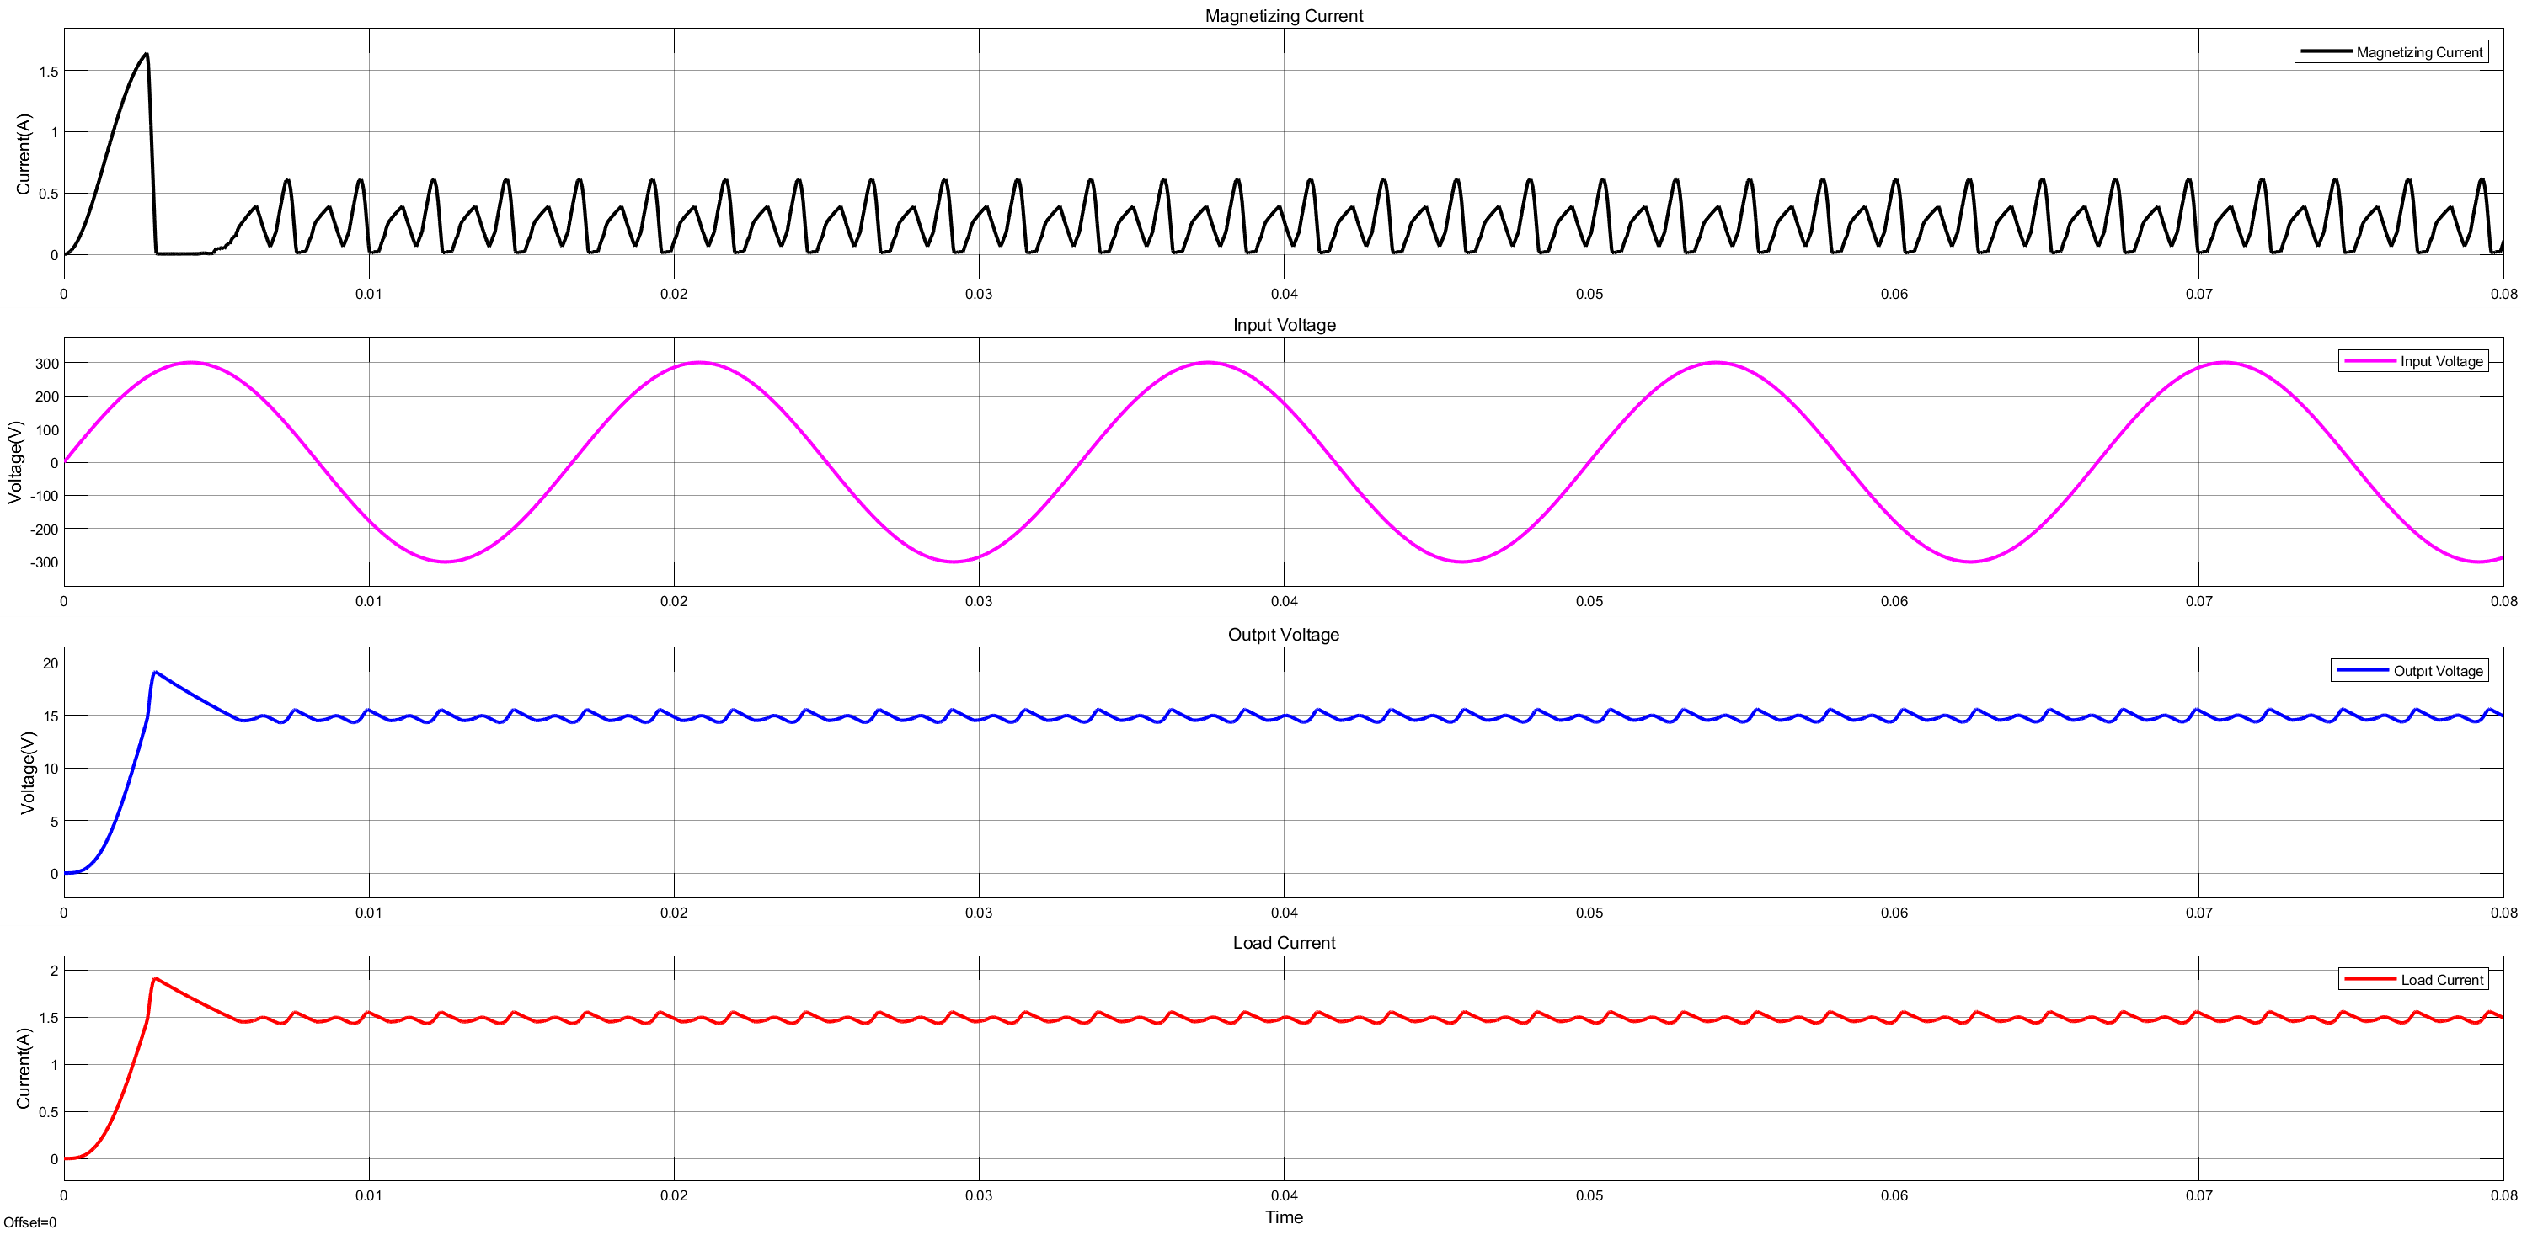

Figure 3: Corresponding waveforms with ideal switches and elements

## 

Leakage inductance is taken as 3 percentage of magnetizing inductance. The MOSFET conduction resistance is 10 ohms, and diode conduction resistance is 5 ohms. Switch Voltage and Switch current are taken at only conduction time.

Without Snubber Circuit:

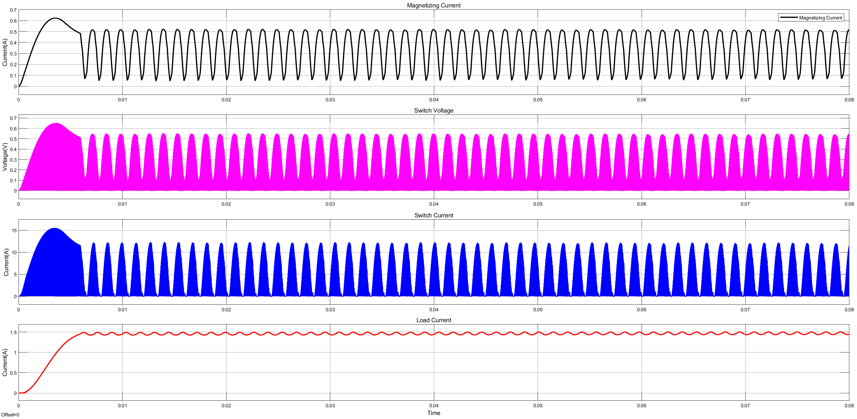

Figure 4: Corresponding waveforms without snubber circuit

With Snubber Circuit:



Figure 5: Corresponding waveforms with snubber circuit

Without snubber circuit, the energy storage is not transferred to load. Load current decreases and output voltage is not provided successfully.

RCD snubber circuit is established. The value of components is found considering switching frequency and time constant RC of the snubber circuit.

R=40k ohm

C= 100 pF

## 1.2. Transformer Design

At this part, we are supposed to design a transformer for our Flyback Converter. There are some properties that are important for designing such as permeability, saturation flux and core loss. Geometry and core type of the transformers determines the properties.

Transformer geometry toroid changes with respect to applications and some geometries are E-core I-core and Toroid core. E- cores are easier to wind and mount by using transformer core former. We chose the core geometry as E-core for that reason. Saturation flux depends on current ratings. Our current rating is small, 1A and we can choose saturation flux density as small. Also, permeability affects the magnetizing inductance which is very important to Flyback design because transformer is used for energy storage elements in Flyback. In addition to this, core loss is very important to determine switching frequency because of the efficiency consideration.

We, as Anka Inc. Team, made a Matlab Script to determine the design parameters with respect to our requirements. The script is given as APPENDIX.

By using this script, we found that:

Requirement Magnetizing Inductance: 10.58mH

Np/Ns= 15 (maximum duty is determined as 0.45) and minimum Np=45 turns

## 1.3. Simulation Results

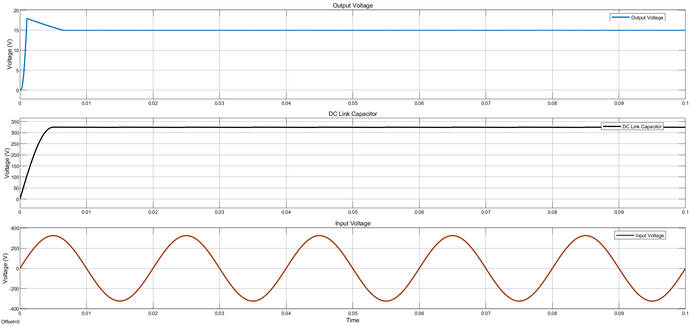

Figure 6: Output, DC Link Capacitor and Input voltage waveforms

With the calculated values and parameters, voltage values are matched with simulation as shown in Figure 6.

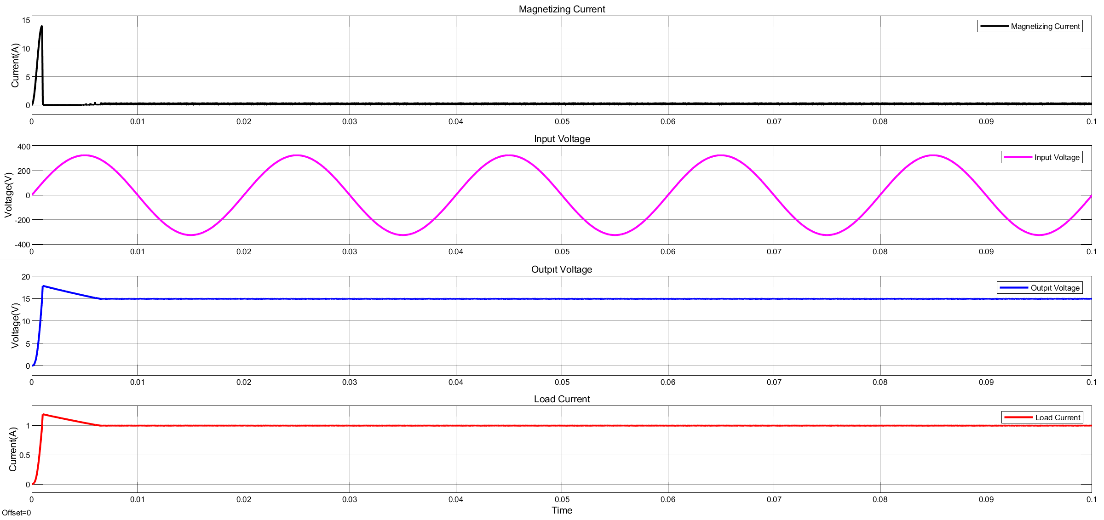

Figure 7: Magnetizing and Output Current waveforms as well as Input and Output Voltages

As shown in Figure 7, the desired voltage and current values are reached. In initial time period, there seems a peaky increase in magnetizing current but it is directly eliminated. Hence, proper operation is proved by simulation results.

|  |  |  |  |
| --- | --- | --- | --- |
|  | Input Power (W) | Output Power (W) | Efficiency (%) |
| %100 | 21.12 | 14.98 | 71 |
| %75 | 17.6 | 11.24 | 63 |
| %50 | 12.1 | 7.48 | 60 |
| %25 | 8.3 | 3.74 | 45 |

Table 2: Efficiency calculation with different load characteristics

As the load is decreased, the efficiency is decreased as shown in Table 2. The reason for that is the losses in transformer stays constant although the changes in output and input powers. Transformer losses have bigger portion in the loss calculations in that case. Therefore, efficiency is decreased with decreasing load. Also, the controller and converters are designed considering %100 load. Therefore, the efficiency is expected to be lower than designed circuit with different load characteristics.

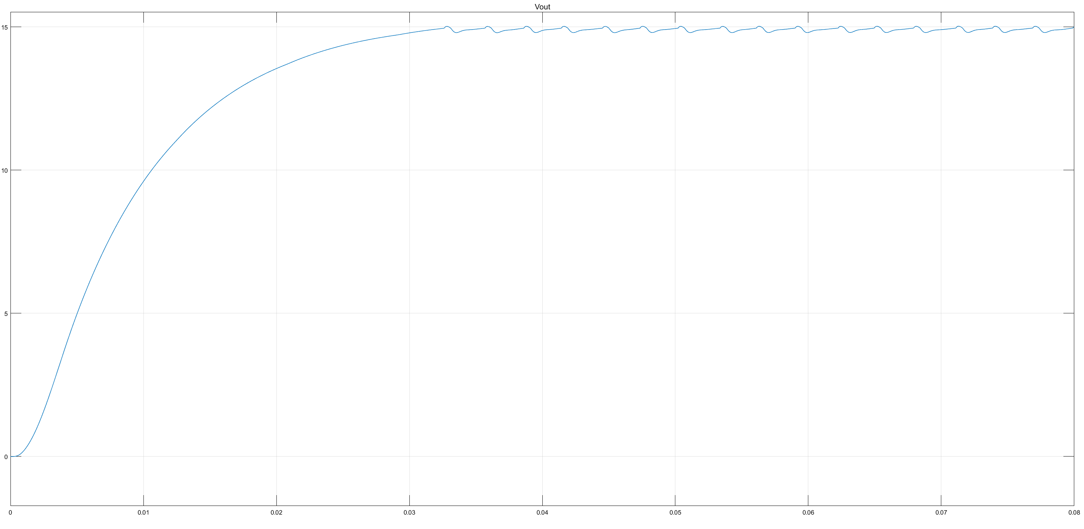

Figure 8: Output waveform with input voltage 210 Vac

%1.3 ripple at 210 Vac is observed in the output voltage waveform which is a reasonable value with desired ripple value less than 5%.

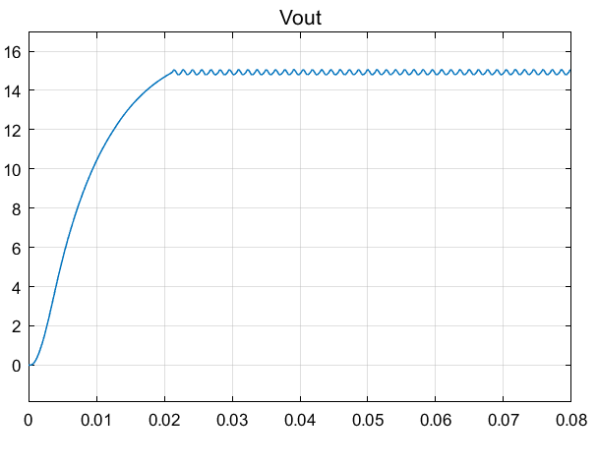

Figure 9: Output waveform with input voltage 230 Vac

%1.6 ripple at 230 Vac is observed in the output voltage waveform which is a reasonable value with desired ripple value less than 5%. Figures 8 and 9 show that the output ripple condition is satisfied with the designed converter design.

## 1.4. Component Selection

### 1.4.1. Transformer

At first we have chosen a core with a bigger transformer area. However, using AWG22 cables, we can reduce the size of transformer which is good for design and implementation. Thus, the final core is chosen as ‘0P43517EC’. It has Kool Mu core and the area of core is 233mm^2. The properties meet our specifications and requirements.

### 1.4.2. Capacitor

Three capacitor is required. One of them is placed after the single phase rectifier to make input voltage of flyback small ripple. Input ripple of flyback affects output voltage level at open loop control with constant duty cycle. However, our system is controlled PI controller and it is not an obligation to create purely DC. In steady-state operation and calculation part, DC link capacitor is chosen electrolytic 33uF and 450V.

Second capacitor is used for filtering output voltage. Output voltage is actually square wave and it should be filtered by capacitance. Duty cycle cannot exceed 40 percent and output voltage cannot exceed 25V. Thus, we chose Electrolytic  470uF and 25 V capacitor.

Final Capacitor is snubber capacitor. Snubber capacitor is used for storing energy from stray inductance at switch is off and it dissipates this energy on parallel resistance at switch is on. The voltage is on capacitor is mirror of output from transformer. Also, loss is minimized by increasing resistance and decreasing capacitance. Capacitor is chosen as 100pF and 1000V.

|  |  |
| --- | --- |
| **Product Number** | **Product Feature** |
| **SD2W336M16025PA** | 33uF and 450 V |
| **PKR1-025V471MF120-T/A5.0** | 470uF and 25V |
| **TMCC02-101K1000VP5A** | 100 pF and 1000V |

### 1.4.3. Diode

Two diode is used. First one is used for RCD snubber. For RCD snubber, diode keeps the DC link voltage at reverse conduction and it leds capacitor charges at switch is off. Thus, at least 400V reverse breakdown is required. Also, out system is switching at 40 kHz and reverse recovery of diode must be faster than it to hold reverse voltages. Thus, it is required ultra-fast diode. Second diode is in output side. Its reverse voltages is smaller because it is in output, low voltage, side. However, it is required to have fast recovery time to not led current pass at switch is on. It is chosen same as RCD snubber diode.

|  |  |
| --- | --- |
| **Product Number** | **Product Feature** |
| **DHG5I600PM** | 600V, 5A and trr= 35ns |

### 1.4.4. MOSFET

Mosfet is used as switch at Flyback converter. Our switch is placed negative side of supply. Thus, we decide a mosfet which is normally turn-off. Also, source is common ground for main circuit, the gate driver can be used as non-isolated with input. Our mosfet current is small thanks to our design specification. Thus, we chose a mosfet which is required reverse voltage. Our maximum reverse voltage is calculated as 540 V. We make overdesign and we choose 900V ,3A mosfet.

|  |  |
| --- | --- |
| **Product Number** | **Product Feature** |
| 3N90 | 3A, 900V, N-CHANNEL |

### 1.4.5. Rectifier Bridge

Input of our project is AC from grid. We chose single phase bridge rectifier. Our current rating is smaller thanks to design specification. We choose 8A, 600 V standard diode bridge rectifier.

|  |  |
| --- | --- |
| **Product Number** | **Product Feature** |
| **GBU8J_B0_10001** | 8A, 600V |

# 2. Test Results

## 2.1. Overall Design

## 2.2. Transformer Results

## 2.3. RLC Measurement

## 2.4. Output Voltage and Current

## 2.5. Input Voltage

## 2.6. Switching Performance

## 2.7. Efficiency

# Conclusion

# Appendix

%%

clear all;

clc;

%% Flyback Parameters

V_line_minimum= 210; % V rms

V_line_max=230 ; % Vrms

V_dc_min= 280; % 5 percentage ripple

V_dc_max=sqrt(2)*V_line_max;

Output_power= 15; % Watt

Efficiency= 0.8 ; % between 0-1

Input_power= Output_power/Efficiency;

%% DC Link Capacitor Calculation

D_ch=0.2; % for capacitor charging duty

F_line= 50; % Line frequency

C_DC = (Input_power*(1-D_ch))/ ...

(F_line*((2*V_line_minimum^2)-V_dc_min^2));

fprintf(' %f microFarad \n',C_DC*1e6);

%% Determination of Maximum Duty Cycle

D_max= 0.45 ; % for CCM mode, it is bigger than 0.5

V_Ro= (D_max/(1-D_max))*V_dc_min;

V_ds= V_dc_max+V_Ro;

%% Lm Determination

f_s= 40000; % Switching Frequecny Hertz

K_f= 1; % for ccm 0.25-0.50

L_m= (( V_dc_min*D_max)^2)/(2*Input_power*f_s*K_f)...

*1e3; % mili Henry

fprintf('% f mH \n', L_m);

L_m=L_m*1e-3;

%% Calculation of peak current of FSP( mosfet, IGBT)

I_edc= Input_power/(V_dc_min*D_max); % average ...

... switching amplifier

Delta_Ids= (V_dc_min*D_max)/(L_m*f_s);

Ids_Peak=I_edc+(Delta_Ids/2);

Ids_rms=sqrt((3*I_edc^2) + ((Delta_Ids/2)^2*D_max/2));

fprintf('%f %f \n',Ids_Peak,Ids_rms);

%% Primary Side Turns Determination

Ae=233*1e-6; % m^2

B_sat=0.3 ; %Tesla

N_p= ((L_m*Ids_Peak)/(B_sat*Ae));

fprintf('%f \n', N_p);

%% Secondary Side Turn Ratio

N_s= N_p/((V_Ro)/(15+0.7));

fprintf('%f \n', N_s);